Flex-Calculator, ItoA

Computer Education

2014312355

Ahn-Hyung-Geun

1.Calculator

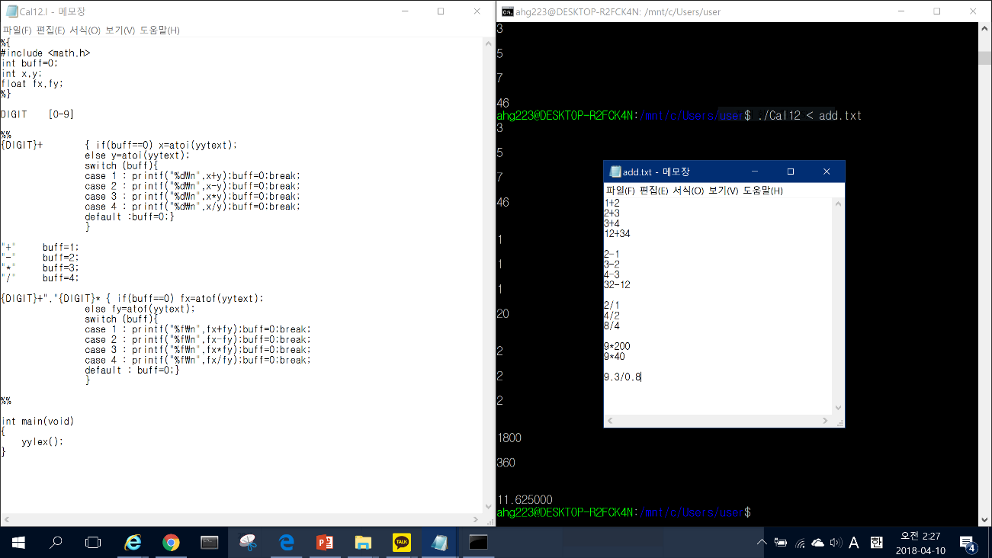

2.ItoA

